Power BI Assignment
Power BI Assignment 1 – Data Transformation & Data Modeling

1. Importing the Data into Power BI.

Import the List of Orders file into Power BI.
In Power BI Desktop, Home > Get data > Text/CSV. In the Open window, browsed and select "List of Orders" and clicked Open to load into Power BI.
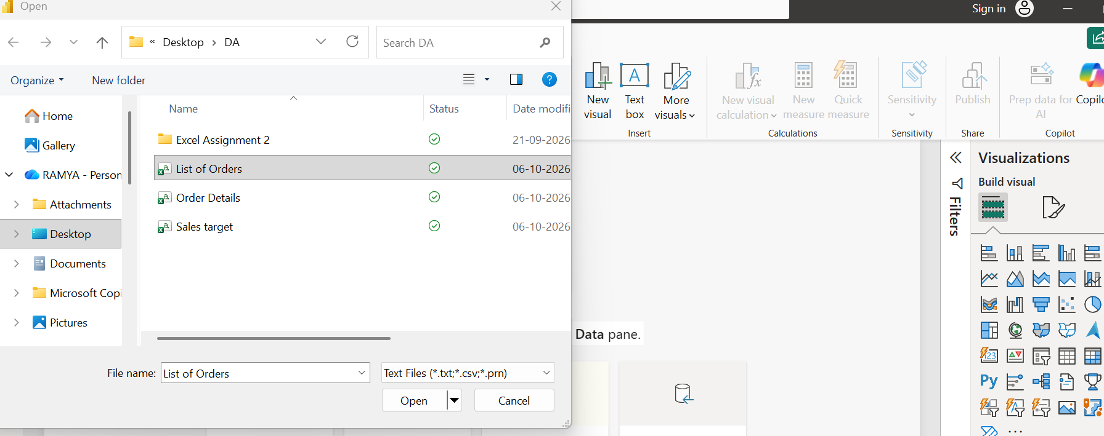
Once opened is showed the Preview of the file and asked if this to be loaded or Transformed
The preview shows the five columns: Order ID, Order Date, CustomerName, State and City. Set the Data Type Detection as "Based on entire dataset". Click Transform Data to open the Power Query Editor.
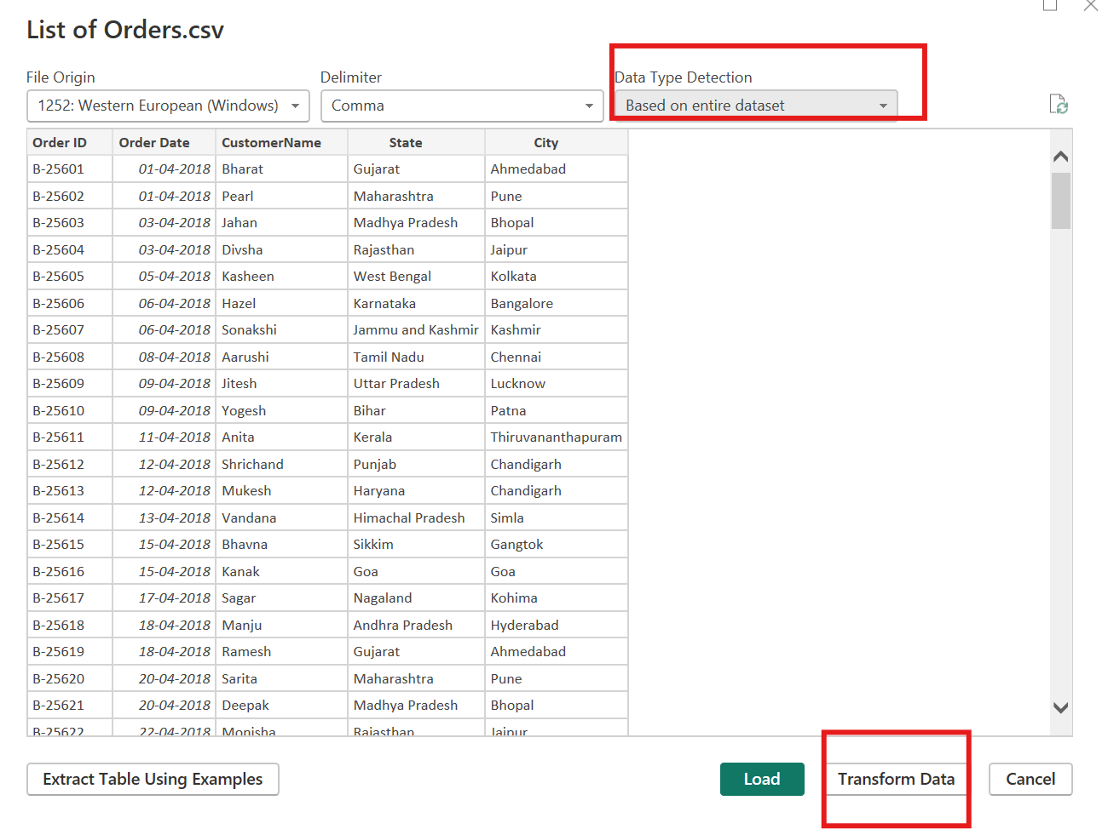

Step 3: Added the other files from the Power Query Editor
Inside the Power Query Editor, Home > New Source > Text/CSV to import the remaining 2 files to power query editor
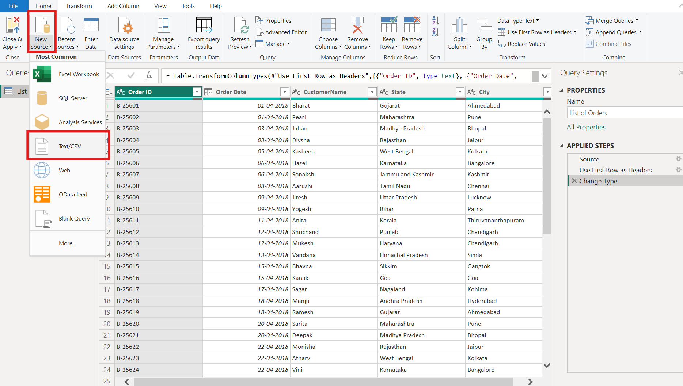

Step 4: Select the Order Details file
In the Open window, choose "Order Details" from the same folder and click Open. The same steps are repeated for "Sales target".
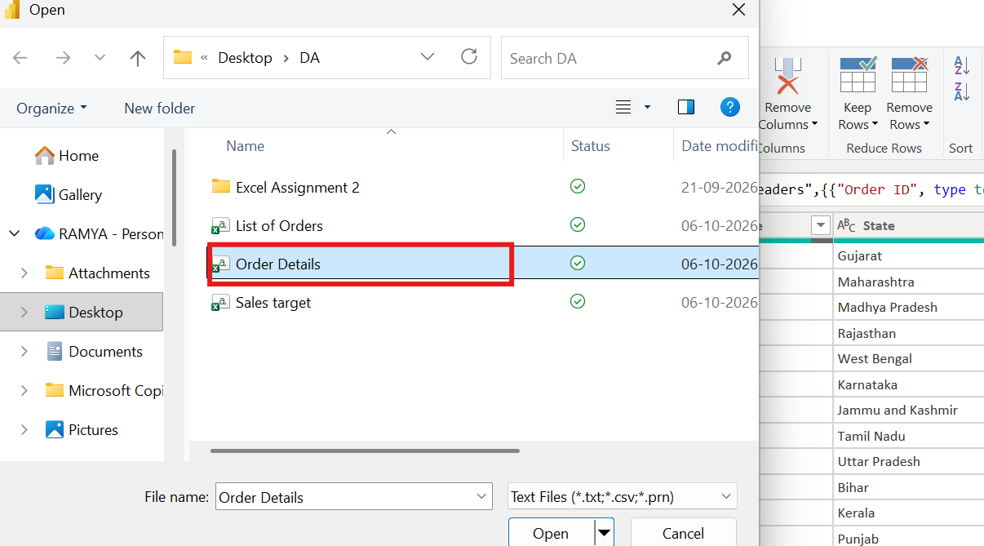

Step 5: Preview Order Details and load to power query editor
The preview shows Order ID, Amount, Profit, Quantity, Category and Sub-Category. Click OK to bring the table into the editor. All three tables now appear in the Queries pane.
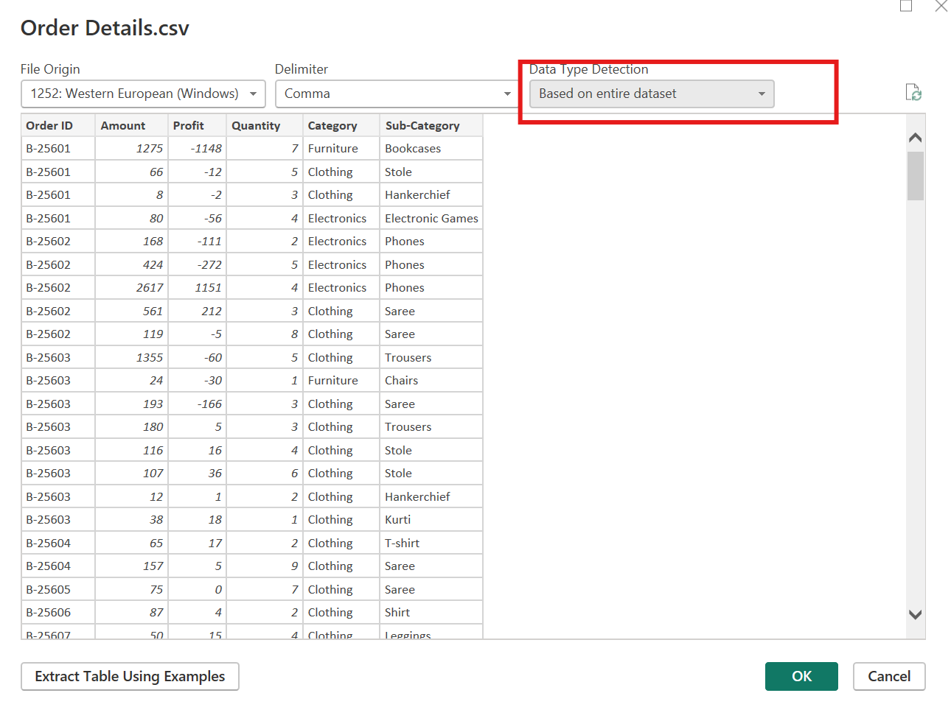

2. Data Transformation

Step 6: Open Keep Top Rows
Select the List of Orders query and go to Home > Keep Rows > Keep Top Rows set as 500, This is used to restrict the table to the first 500 rows.
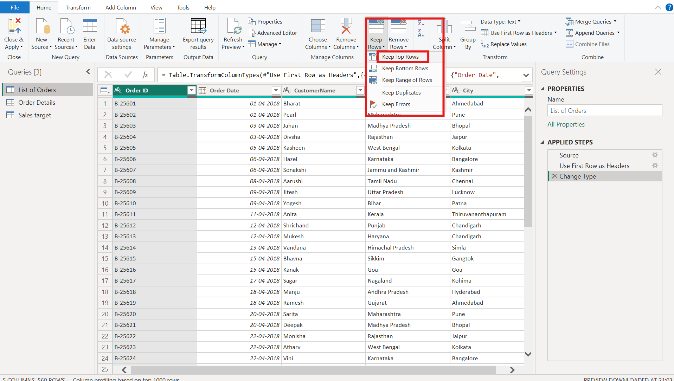

Step 7: Enter 500 rows
In the Keep Top Rows window, type 500 as the number of rows and click OK.
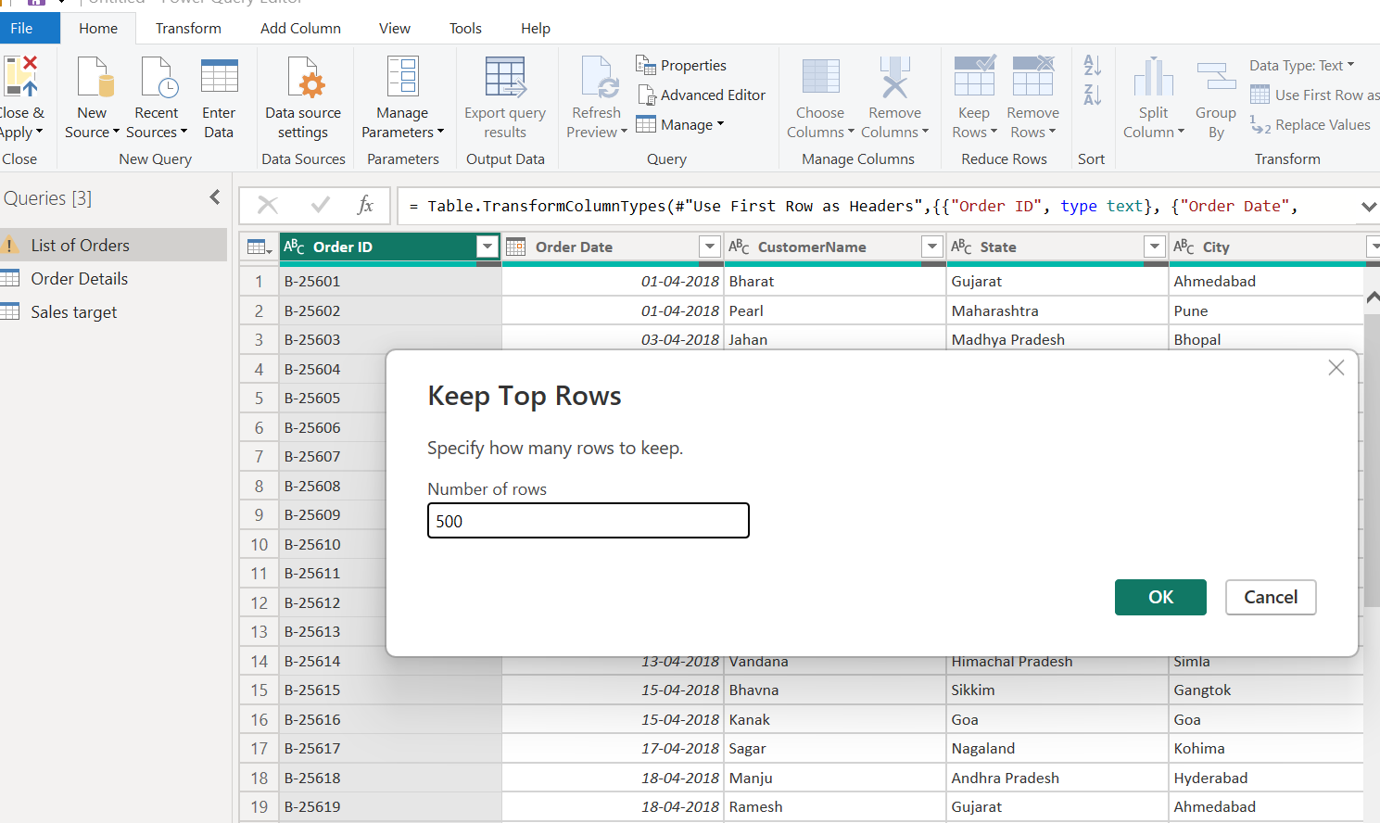

Step 8: Check the row count
Transform > Count Rows returns 500, which confirms that only the first 500 rows were kept. The Applied Steps pane shows the new steps Kept First Rows and Counted Rows. The count is only a check, so the Counted Rows step is deleted afterwards to return to the table.
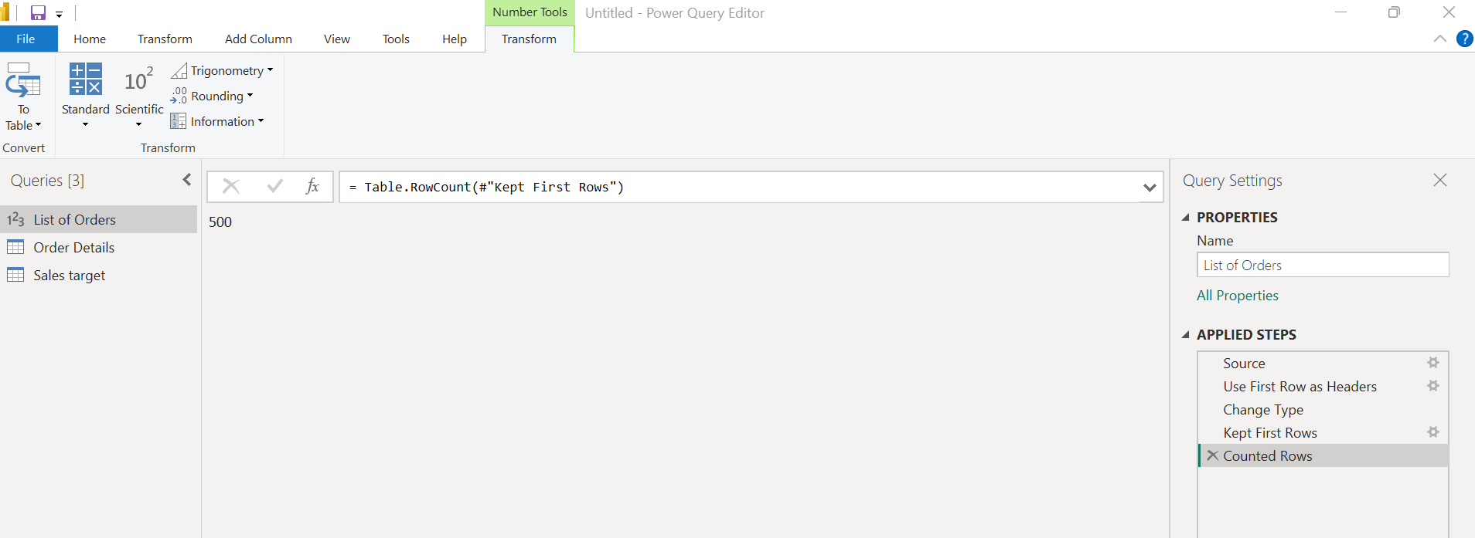

Step 9: Set Order Date to the Date data type
Click the data type icon on the Order Date column header and choose Date from the list.
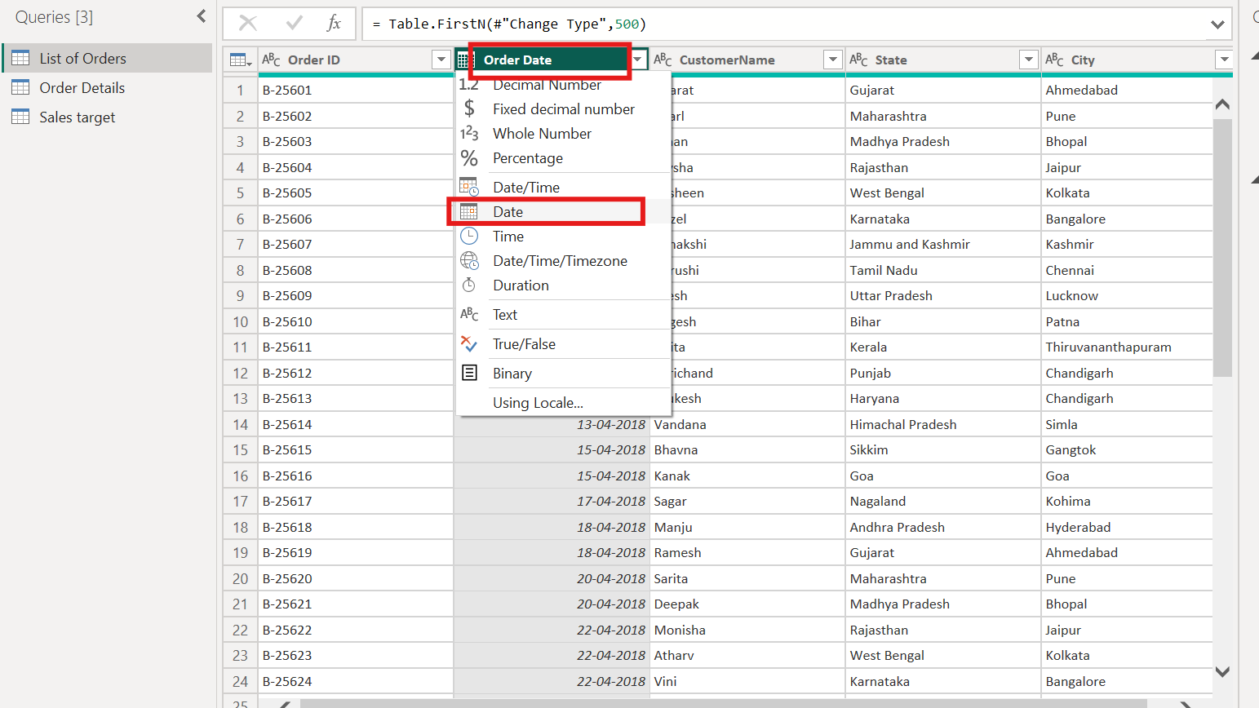

Step 10: Convert CustomerName to proper case
Select the CustomerName column and go to Transform > Format > Capitalize Each Word. This capitalizes the first letter of every word in each name.
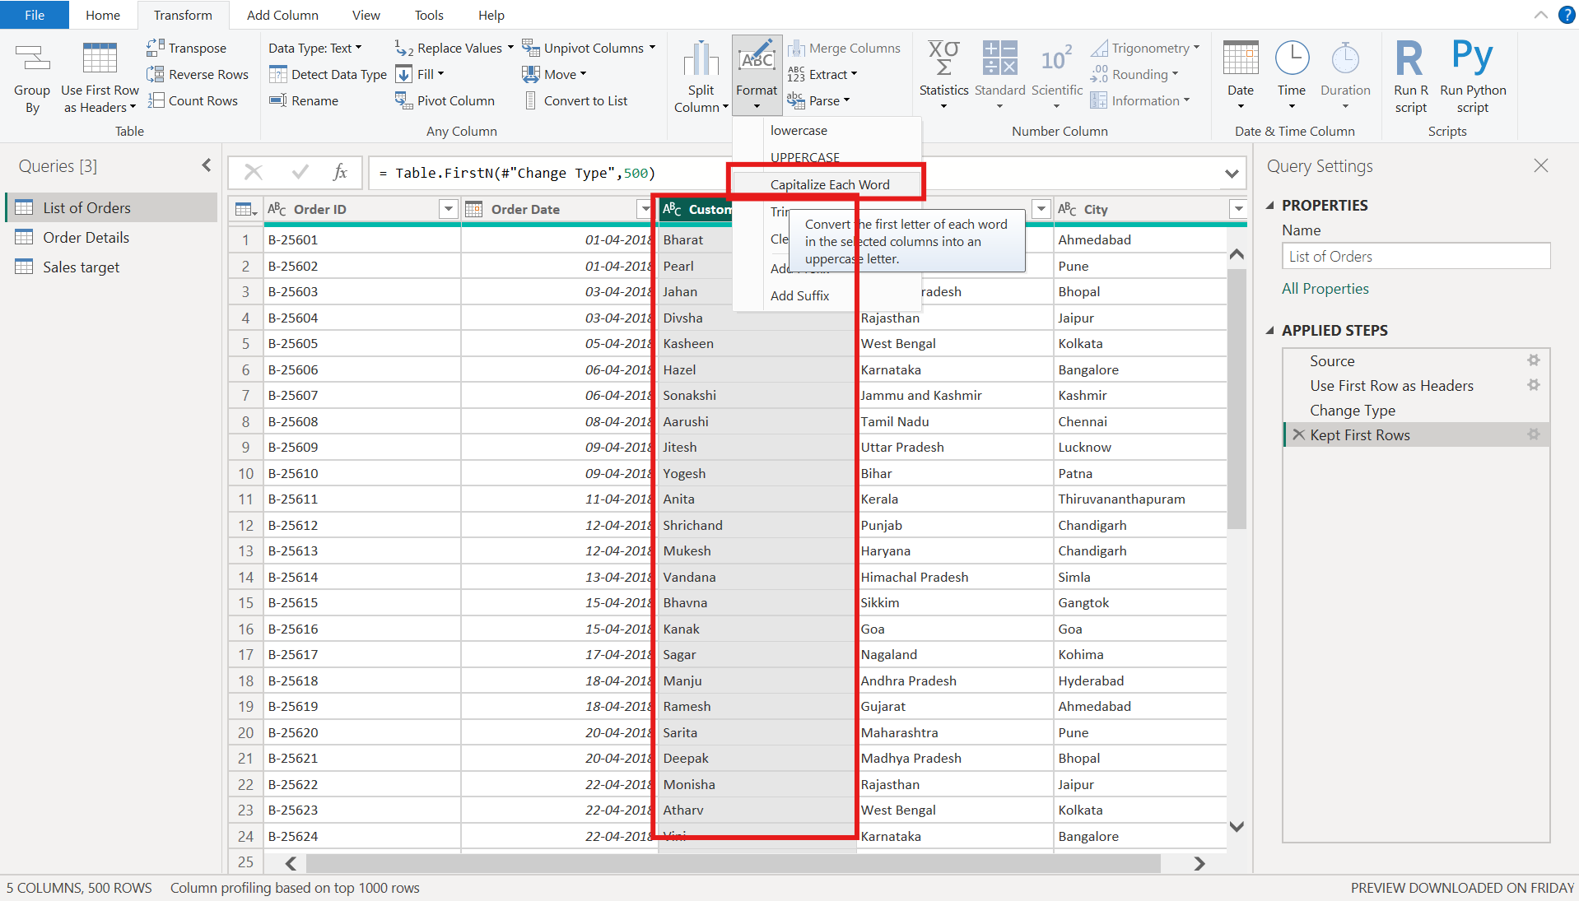

Step 11: Change Amount to Fixed Decimal Number
In the Order Details table, click the data type icon on the Amount column and choose Fixed decimal number.
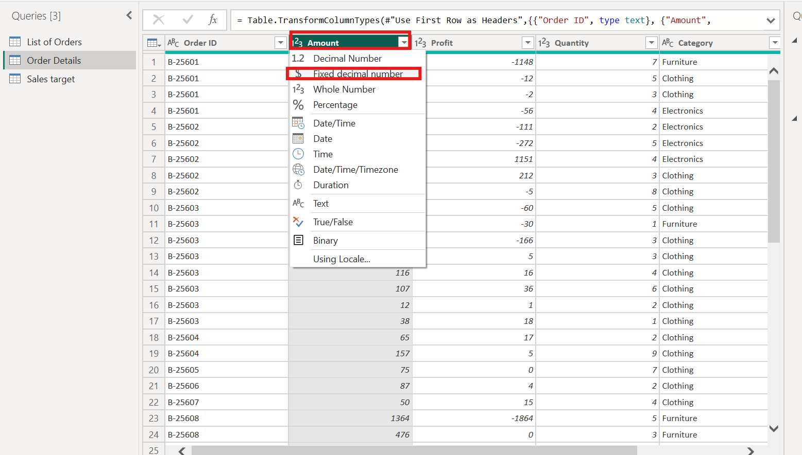

Step 12: Change Target to Fixed Decimal Number
In the Sales target table, the Target column is set to Fixed decimal number in the same way. The $ icon and values such as 10,400.00 confirm the new type.
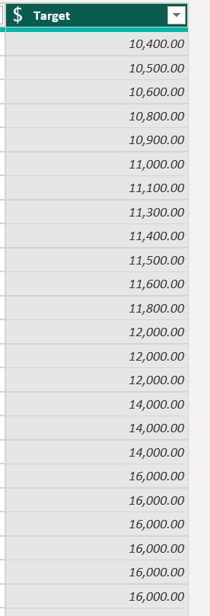

Step 13: Merged State and City into Location
Selected the State and City columns and under Transform > Merge Columns, Choose a custom comma and a space separator, type Location and said OK to merge the columns.
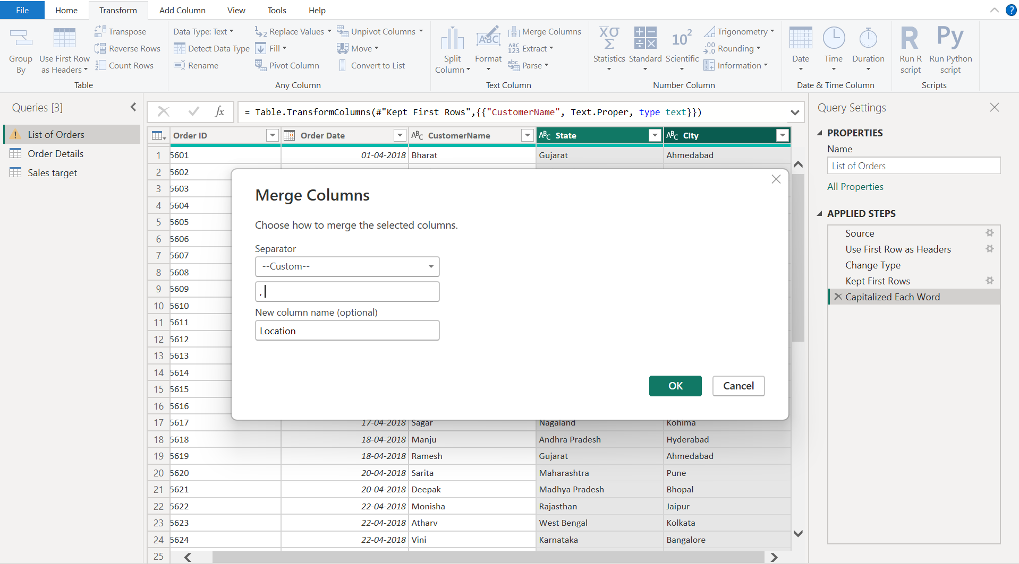

Step 14: Corrected the Profit data type
The Profit column in Order Details was detected as text. Its data type is changed to Whole Number so that it can be used in the Profit Margin calculation.
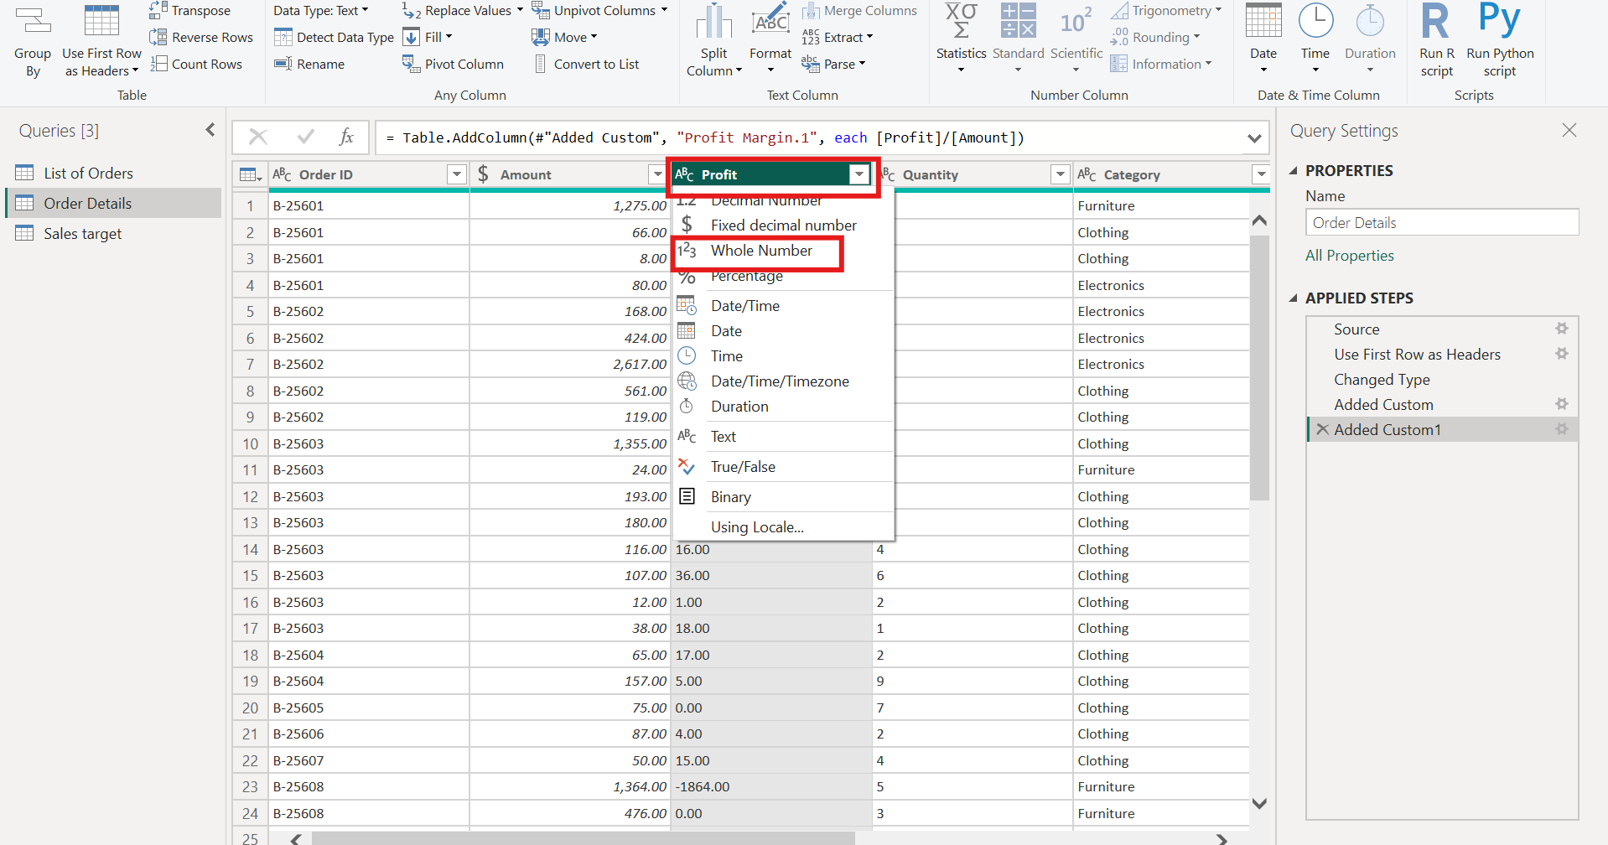

Step 15: Created the Profit Margin column
Under Add Column > Custom Column. Entered Profit Margin as the column name, typed the formula [Profit]/[Amount] and clicked OK to get the profit margin value.
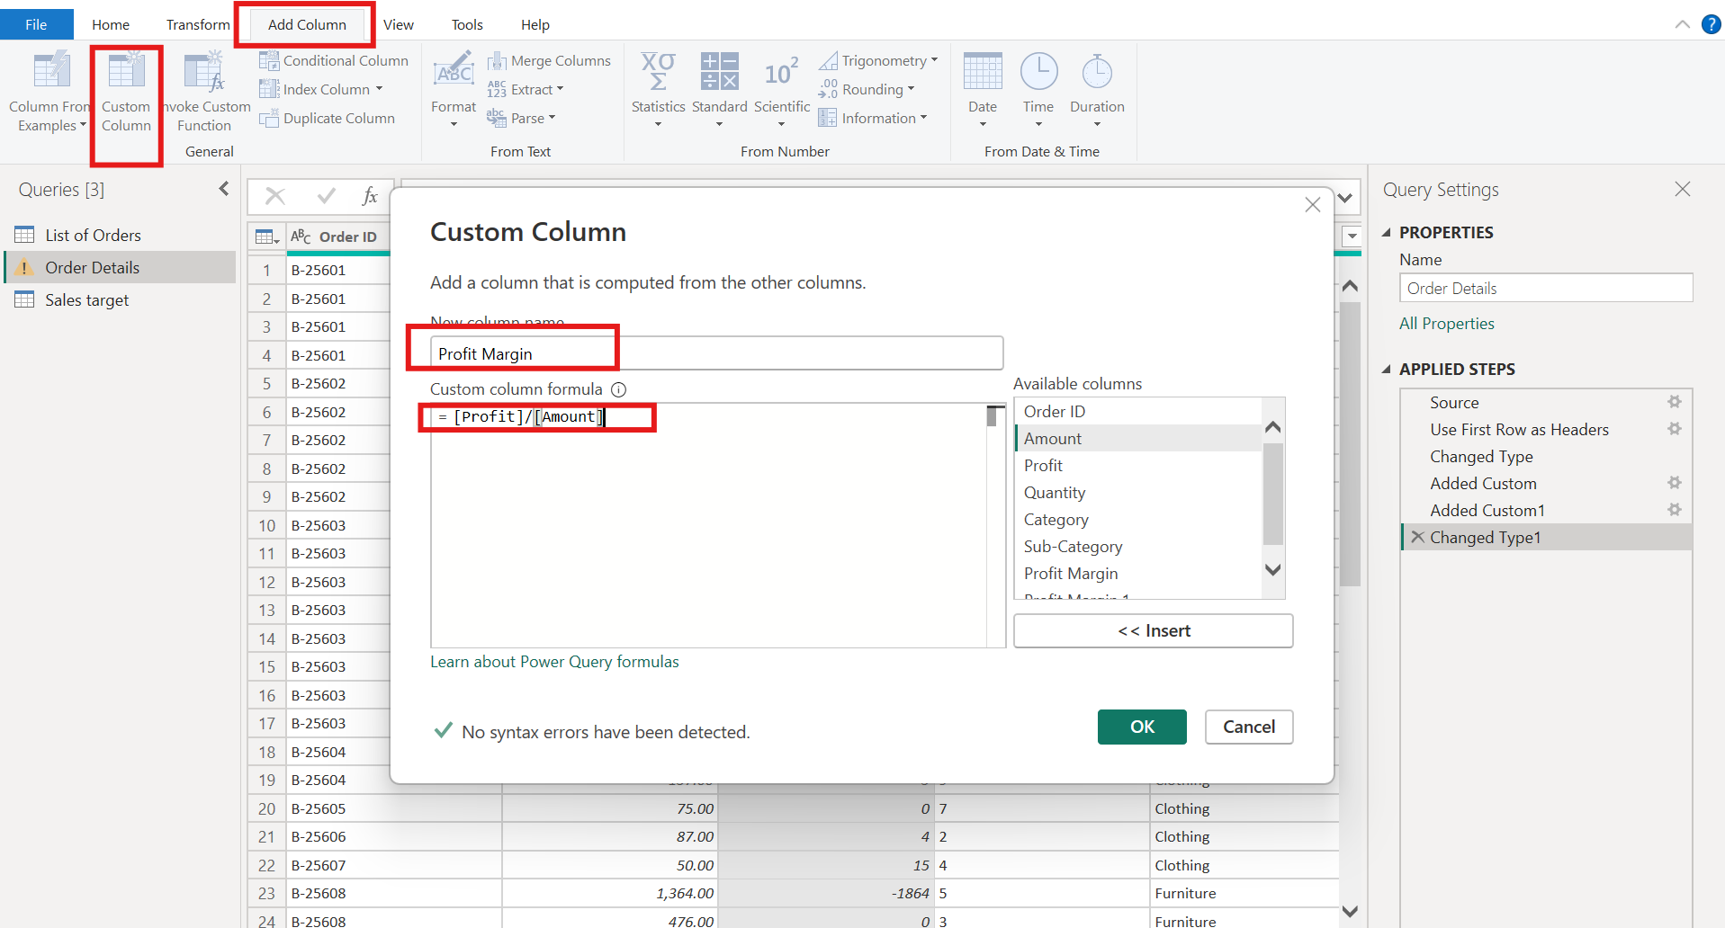

Step 16: Profit Margin result
The new Profit Margin column shows profit divided by amount for every row. For example, the first row (a loss) gives about -0.90.
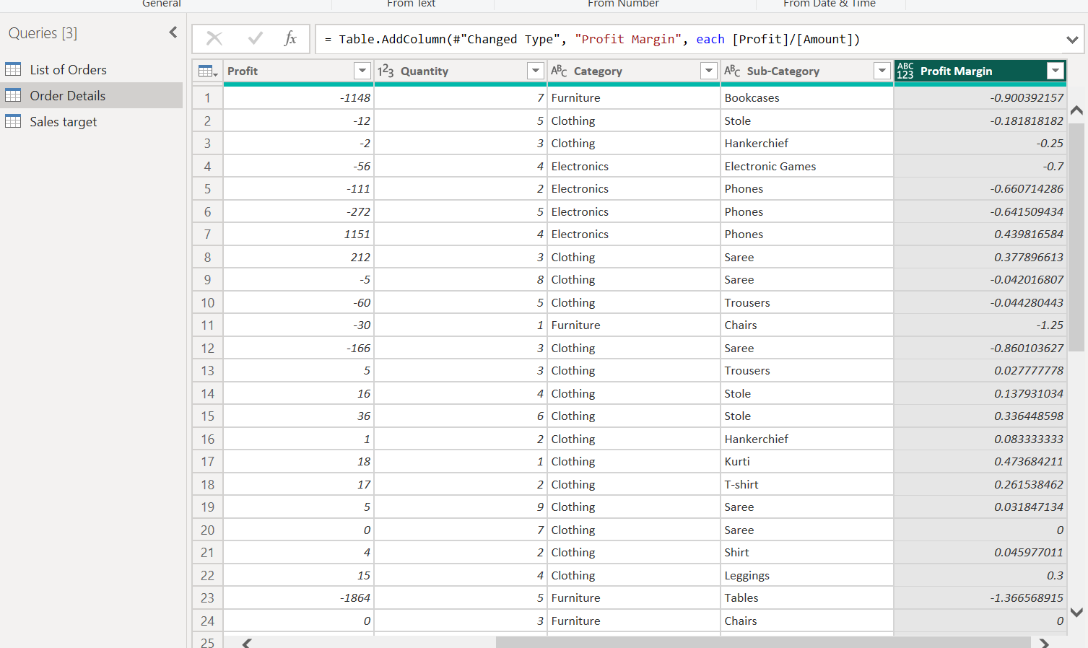

Step 17: Profit status conditional column
Under Add Column > Conditional Column. The conditions are as IF Profit equals 0 then return "Break-Even", ELSE IF Profit is greater than 0 then "Profit", ELSE IF Profit is less than 0 then "Loss". The new column is named as Profit Column.
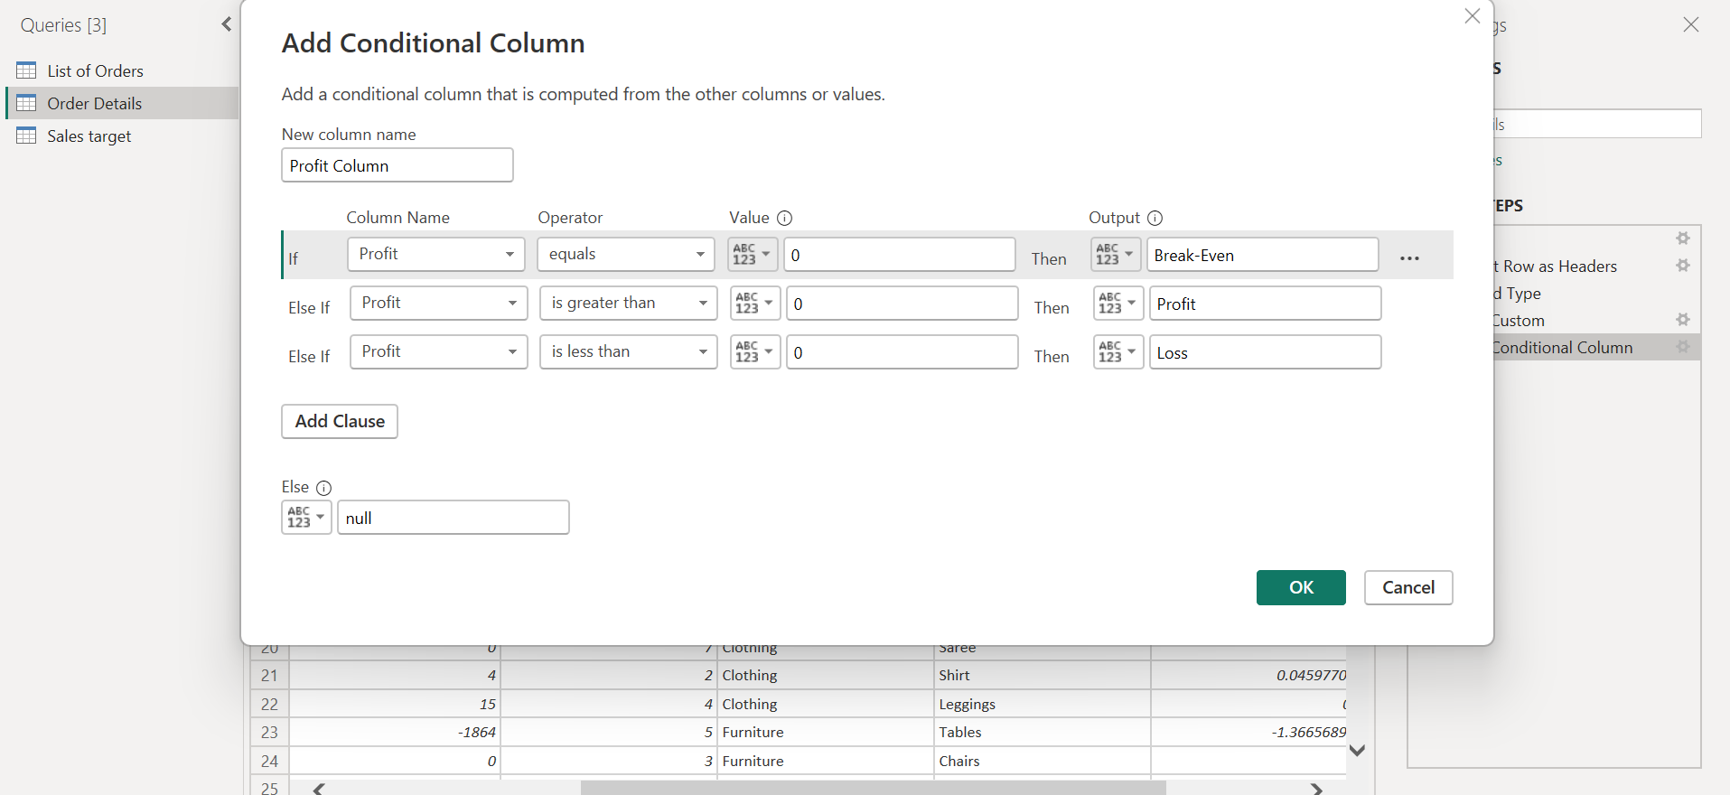

3. Merging Data (Joins)

Step 18: Merge the two tables into a new query
Go to Home > Merge Queries > Merge Queries as New. This creates a new table without changing the original two.
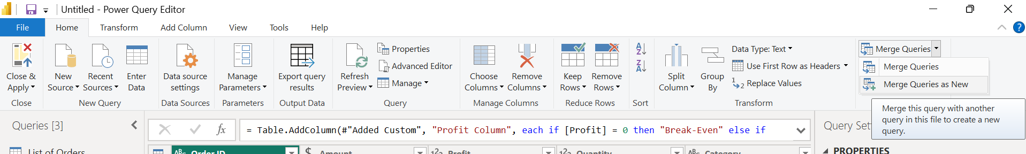

Step 19: Merging Data (Joins):
Selected the List of Orders as the top table and Order Details as the bottom table, then selected the Order ID column in each. Join Kind is set to Inner (only matching rows). The message at the bottom confirms that all 500 rows of the first table matched.
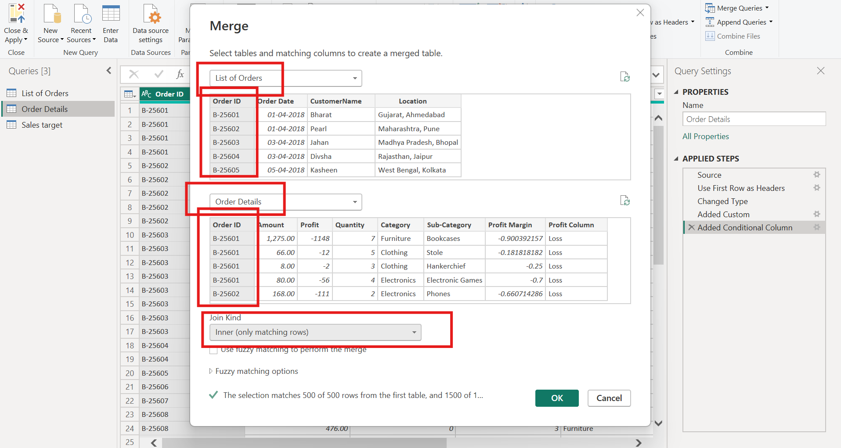

Step 20: Expand the Order Details column
Click the expand icon on the new Order Details column. Tick every column except Order ID, which is already present, and click OK. The new table is then renamed Orders Data.
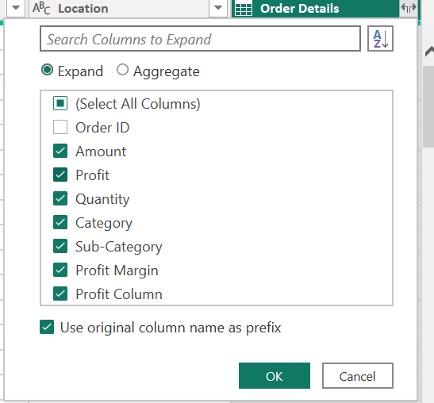

4. Handling Missing and Duplicate Data

Step 21: Trim extra spaces
In Orders Data, selected the text columns and under Transform > Format > Trim. This removes leading and trailing spaces so that the same value is not treated as two different values.
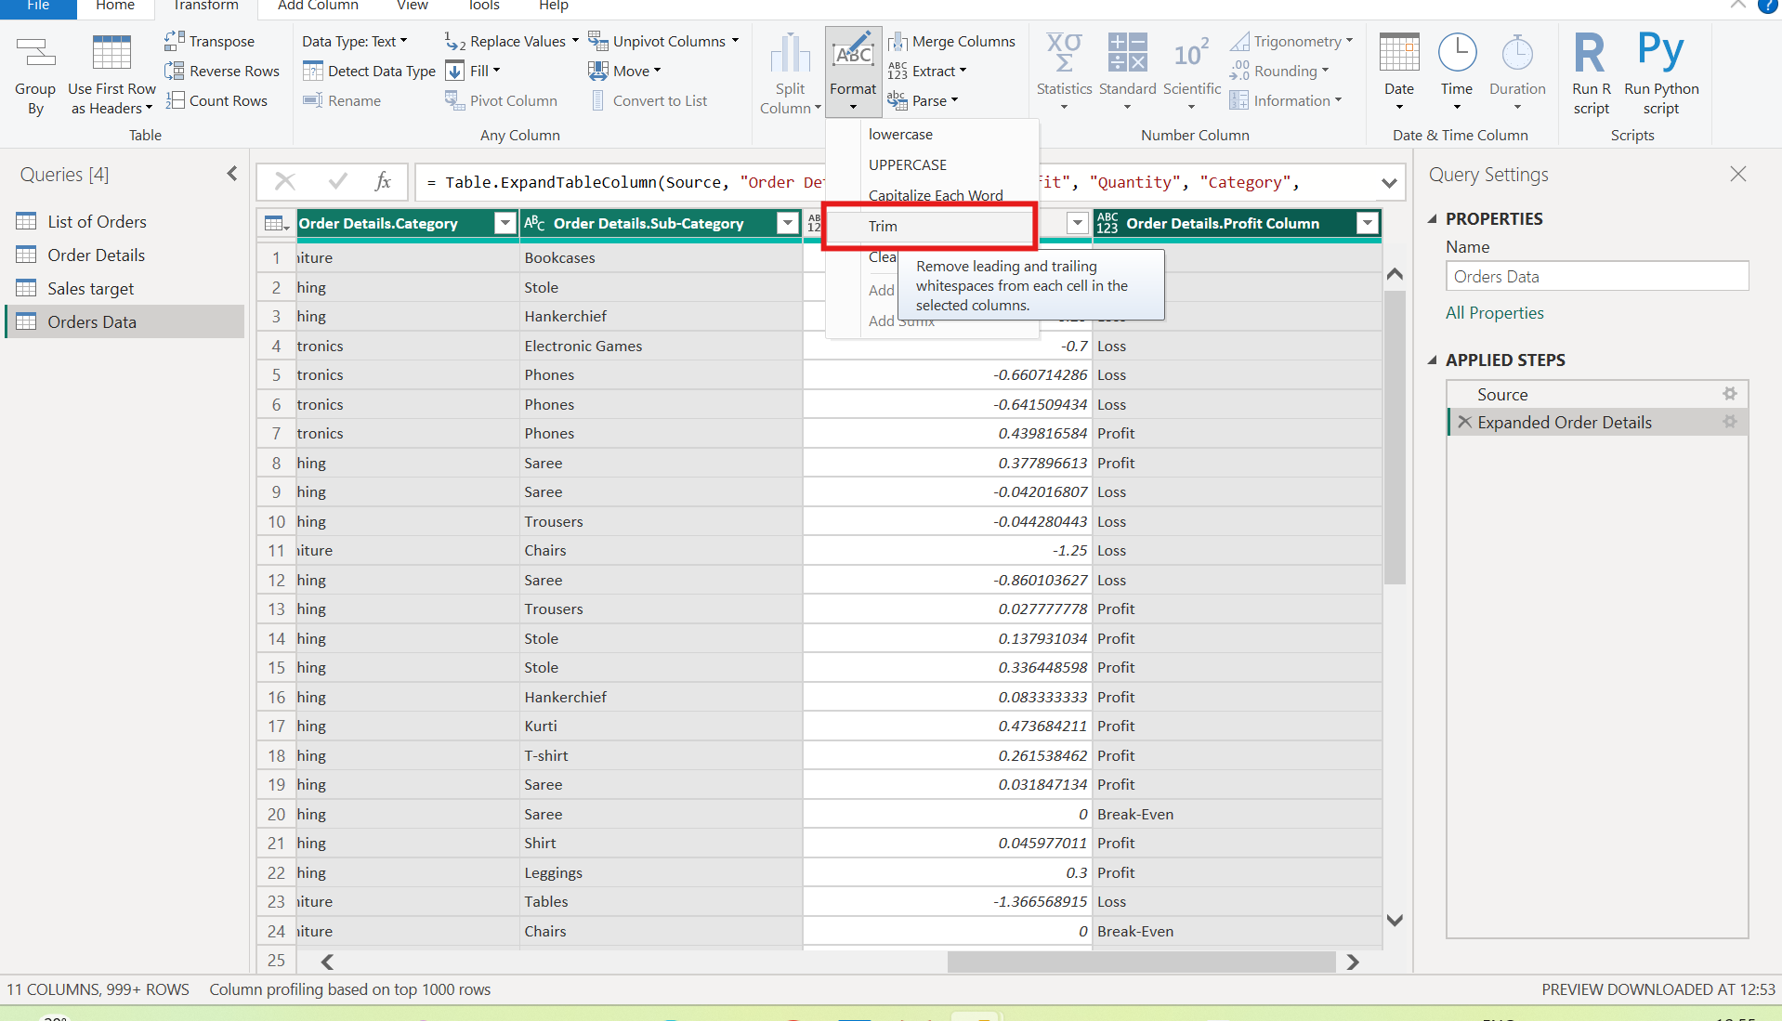

Step 22: Remove duplicate rows
After the Trimmed Text and Cleaned Text steps, under Home > Remove Rows > Remove Duplicates to delete repeated rows from Orders Data.
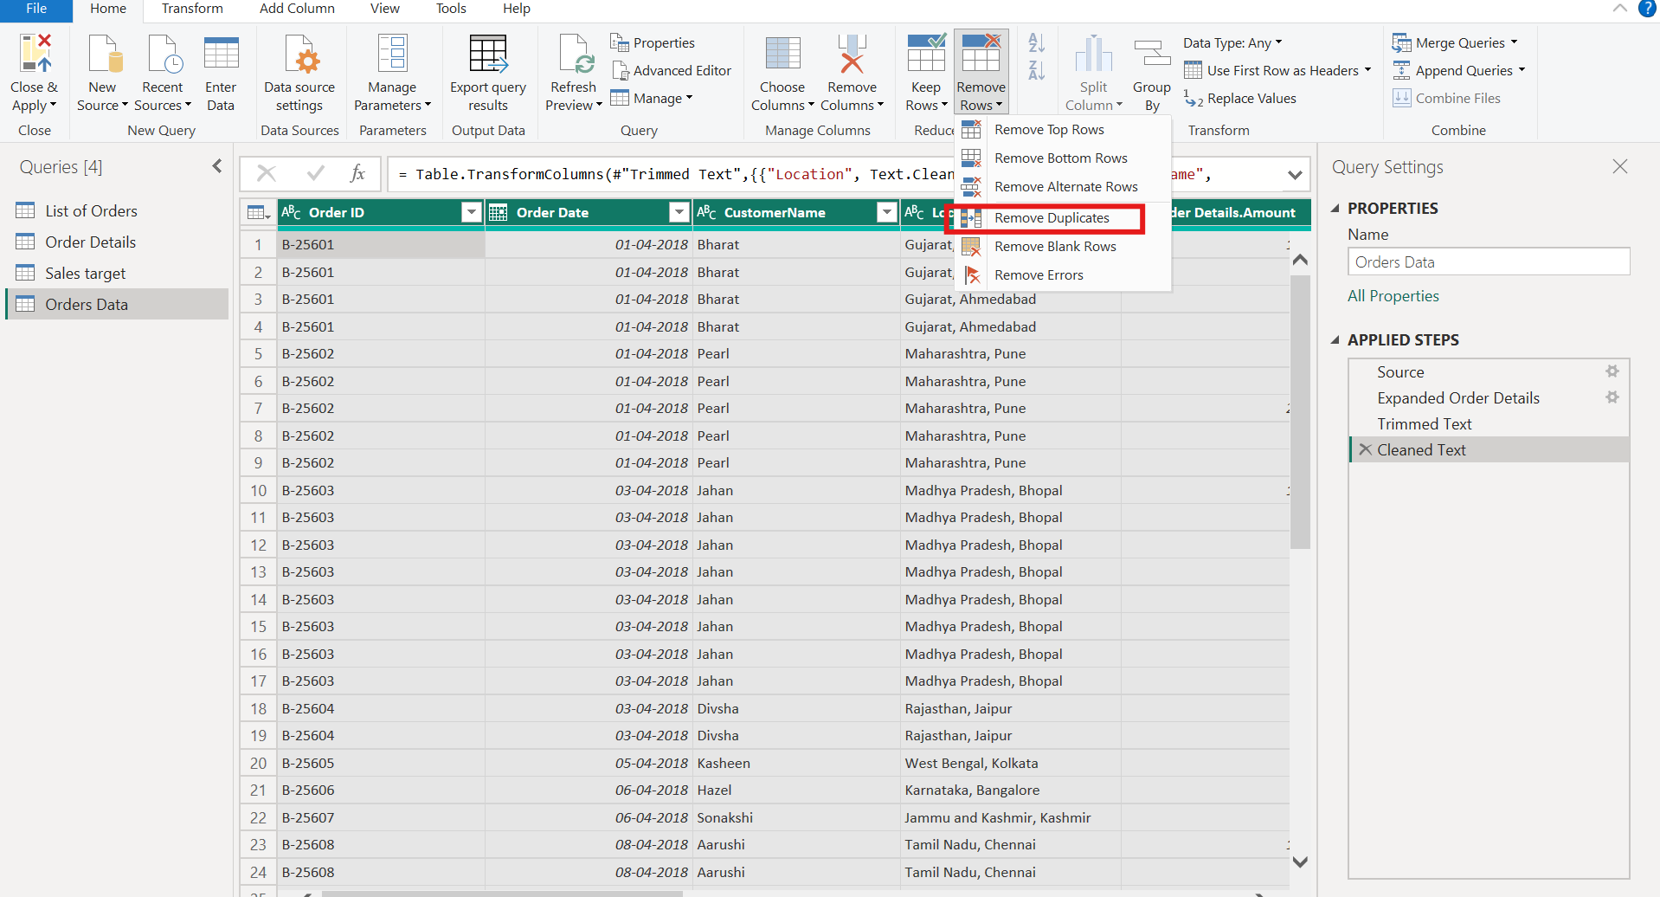

Step 23: Check the row count of the merged table
Transform > Count Rows on Orders Data returns 1500, the total number of order lines after the merge and cleaning.
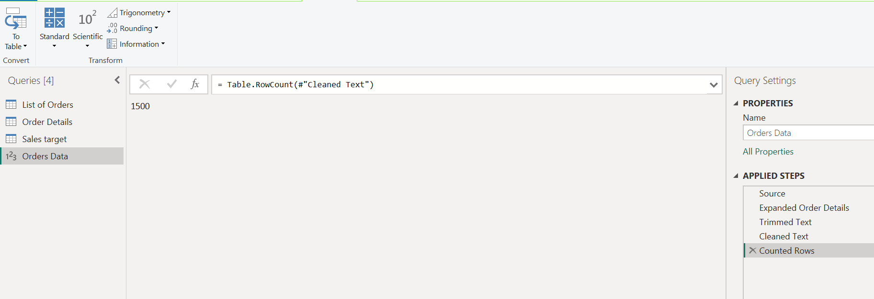

5. Sorting and Filtering Data

Step 24: Sort Order Date in descending order
On a copy of Orders Data (shown as Orders Data (2)), clicked the filter arrow on Order Date and choose Sort Descending. The most recent orders now come first.
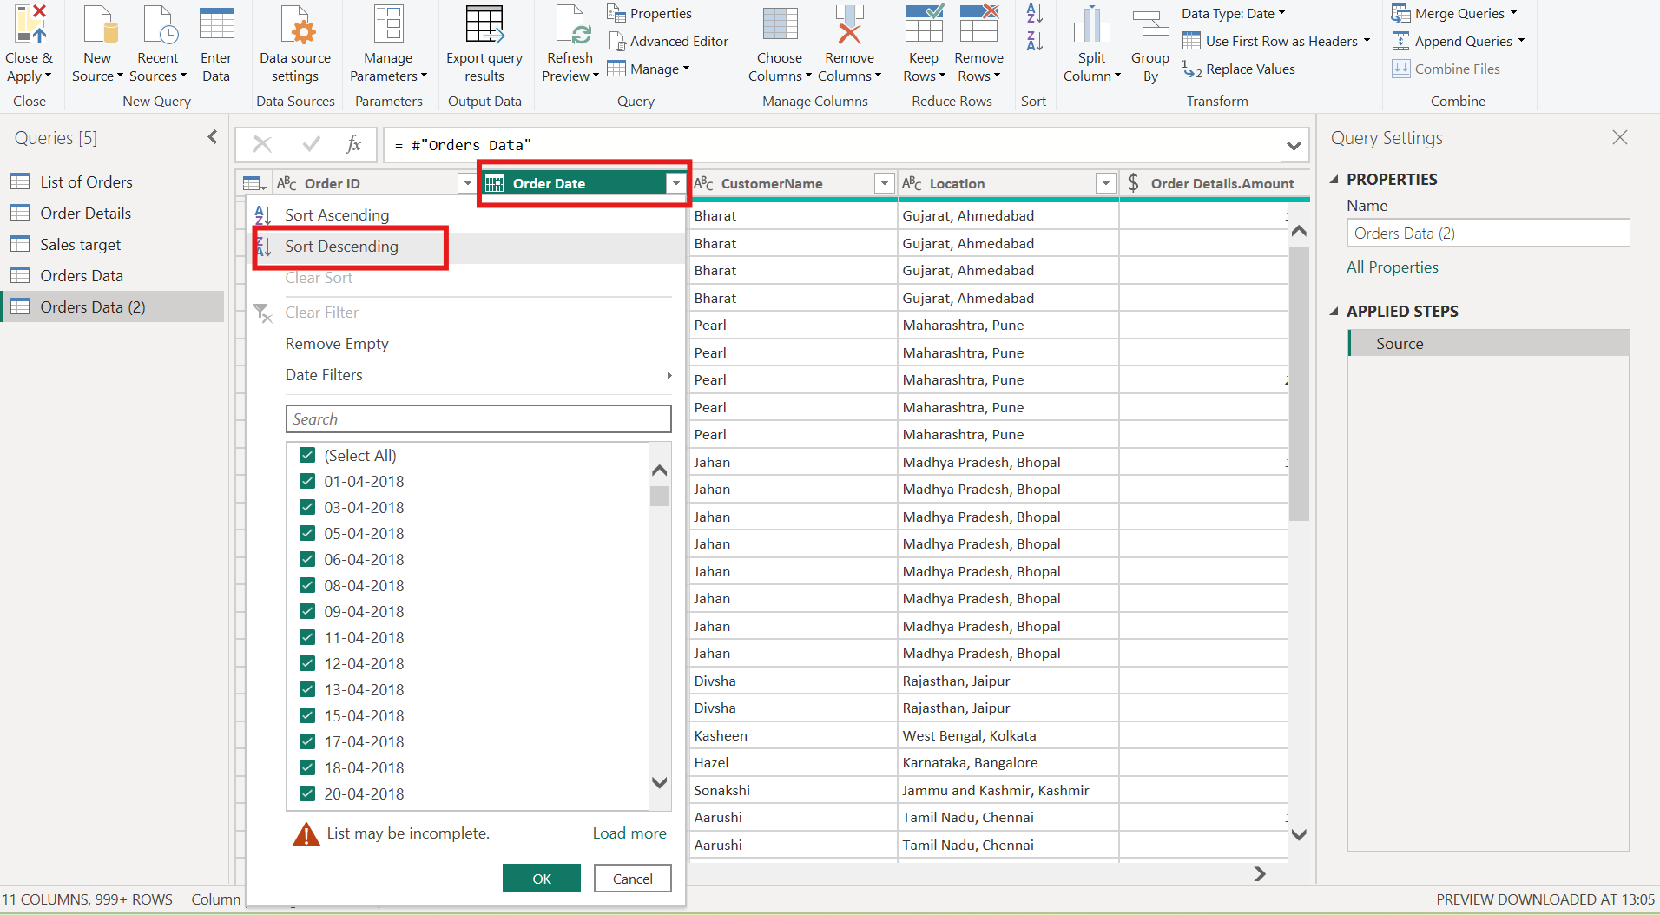

Step 25: Review the sorted table and open the Location filter
The Sorted Rows step uses Order Date in descending order, so the latest order (B-26100 on 31-03-2019) is at the top. To filter by region, the Location filter list is then opened and only one location (Karnataka, Bangalore) is ticked.
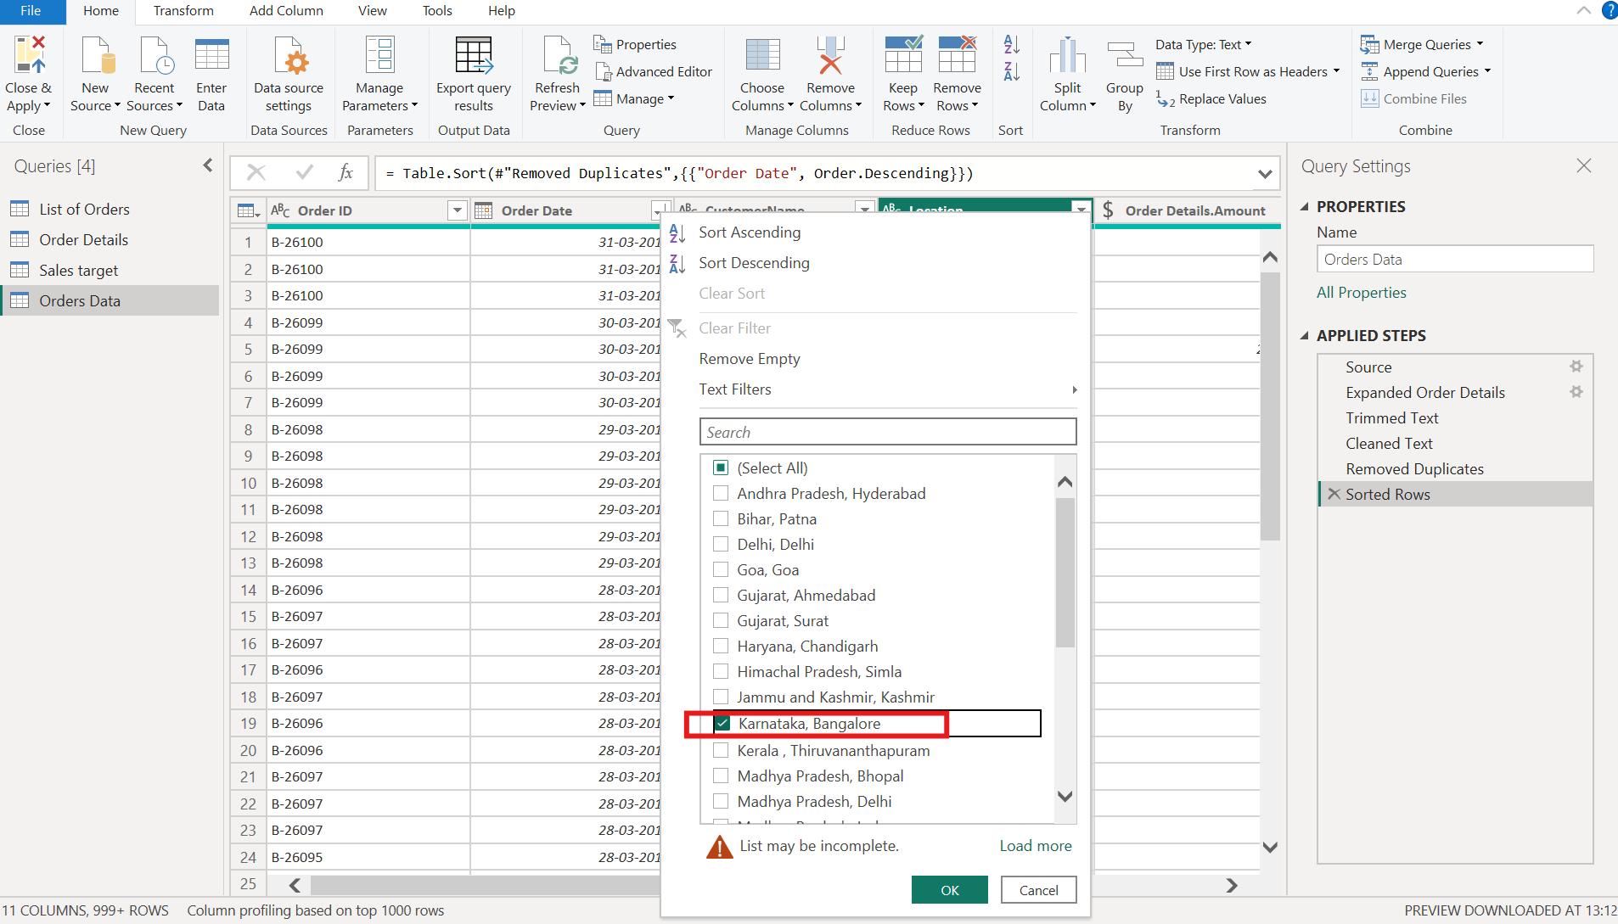

Step 26: Filtered result
Only the rows where Location is Karnataka, Bangalore remain (54 rows), and the Applied Steps pane shows the new Filtered Rows step.
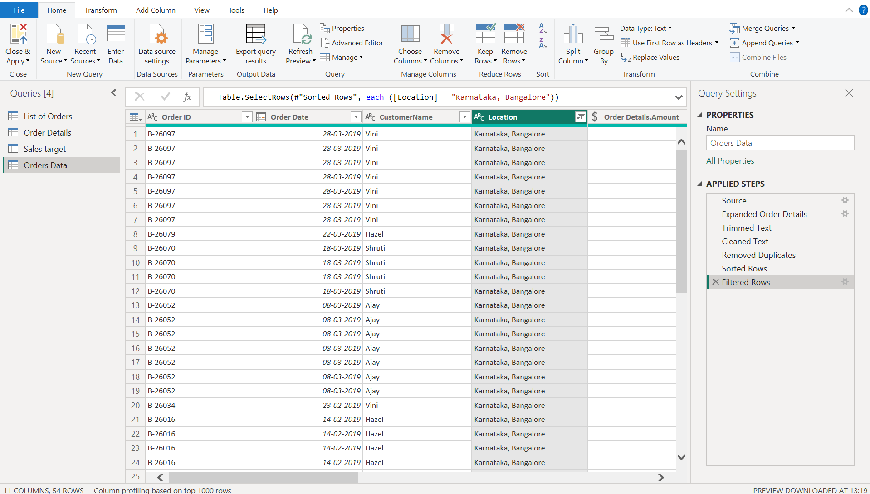

6. Grouping and Aggregating Data

Step 27: Duplicate the table for grouping
Right-clicked the Orders Data query and chose Duplicate. Each grouping below is done on its own copy, so the original data is not changed.
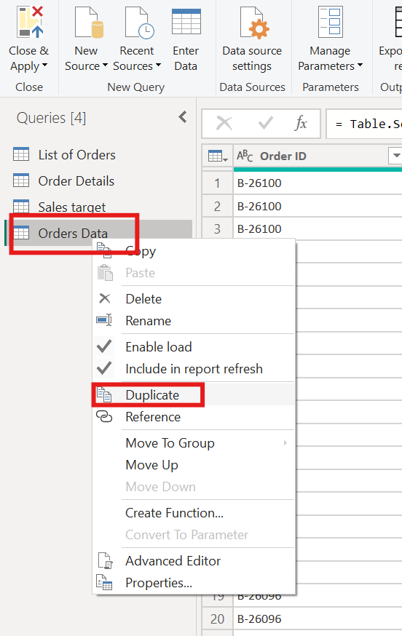

Step 28: Count of each Order ID
Under Transform > Group By. Group by Order ID, named the new column Count and choose the operation Count Rows. The result (query Count of Order ID) lists each order with its number of items, for example B-25601 has 4.
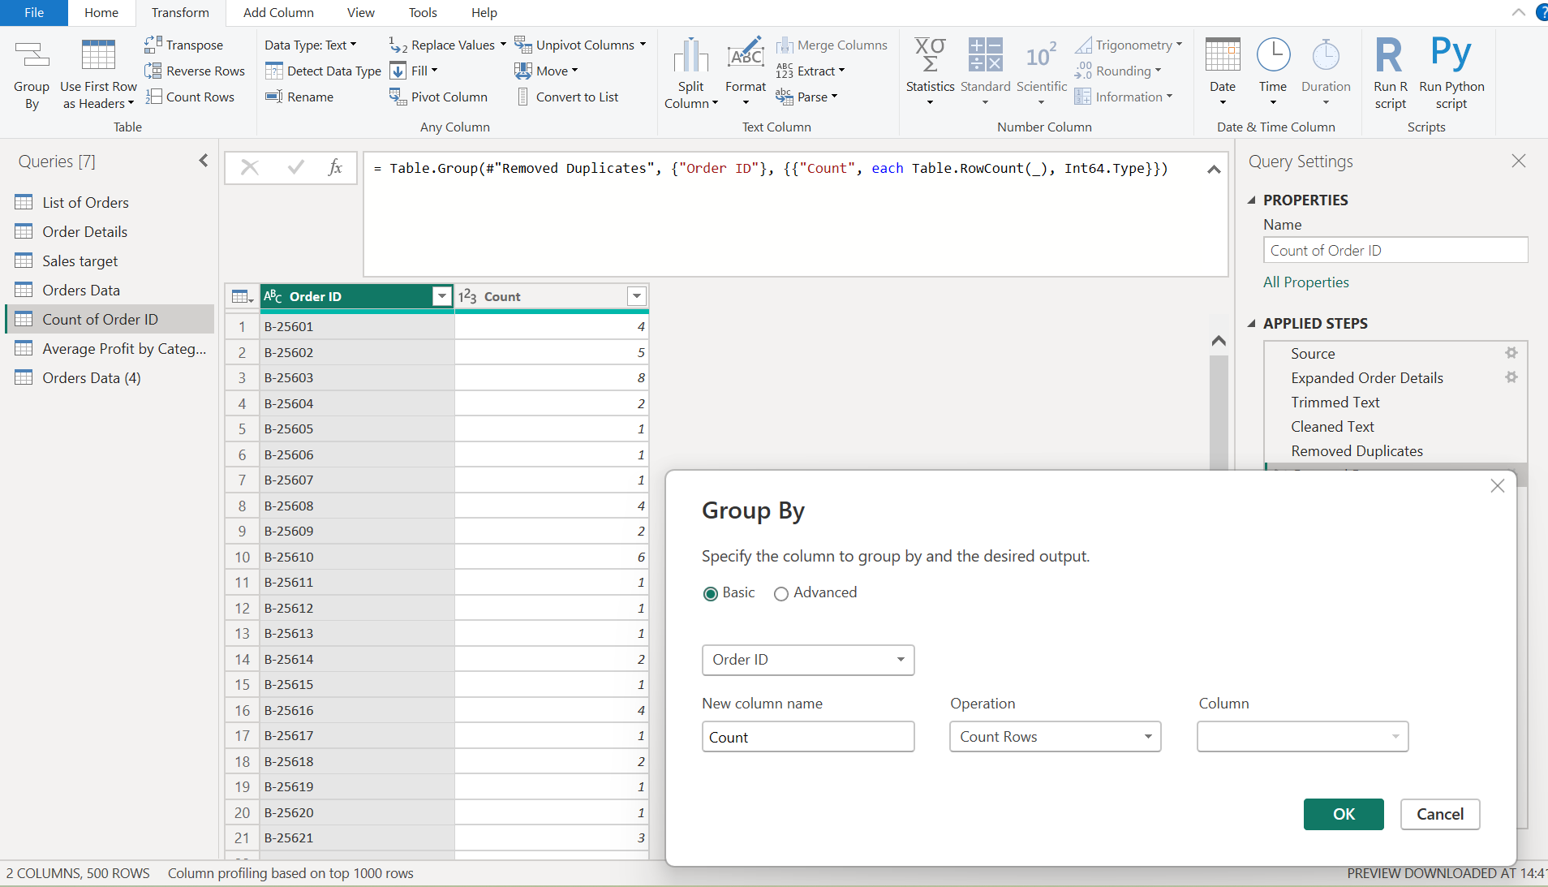

Step 29: Average profit by Category
Used Group By again on another copy Order data. Group by Order Details.Category, named the new column Avg.Profit By Category and choose the operation Average on Order Details Profit.
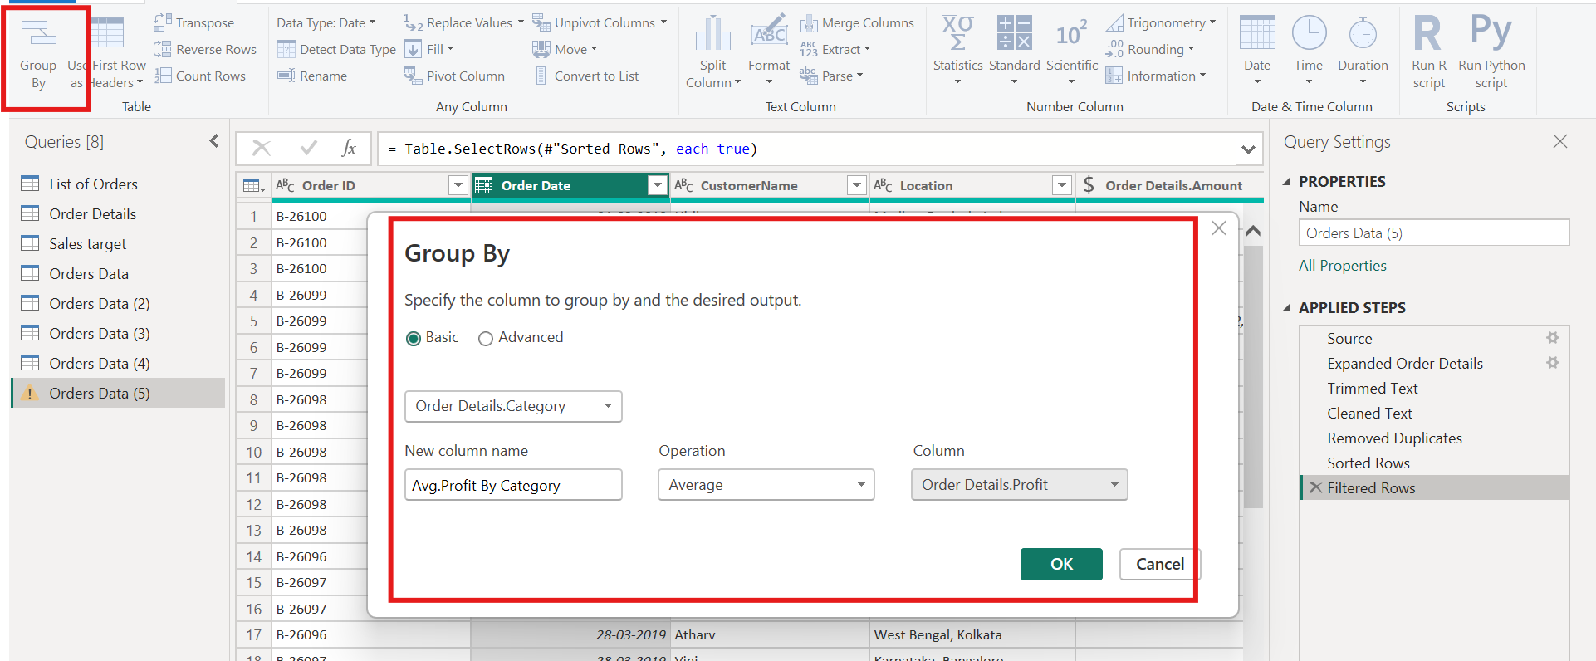

Step 30: Average profit result
The result shows one row per category: Furniture about 9.46, Clothing about 11.76 and Electronics about 34.07.
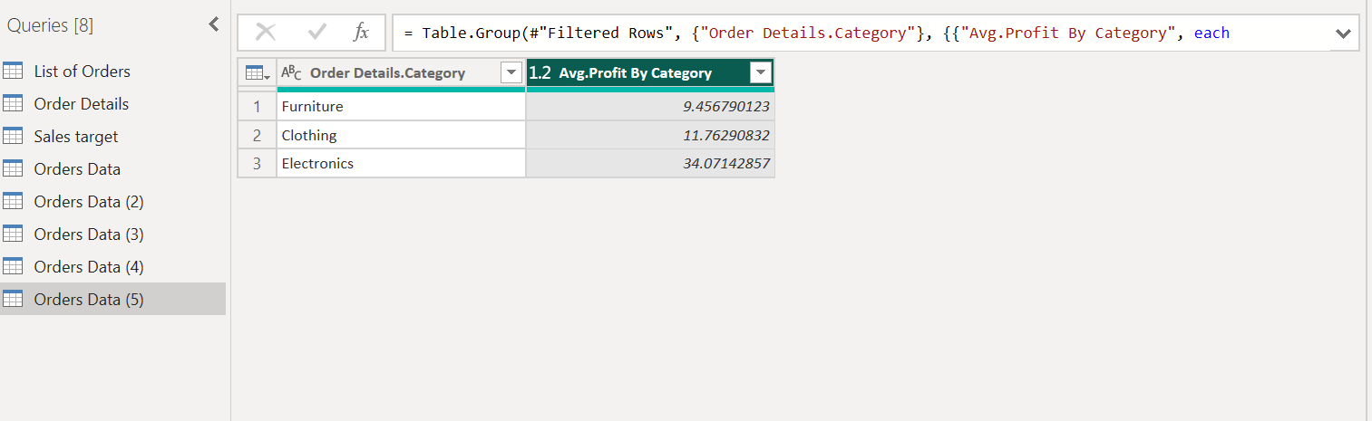

Step 31: Total amount by Sub-Category
On a third copy, group by Sub-Category, name the new column Revenue by S-Cat and choose the operation Sum on Order Details.Amount.
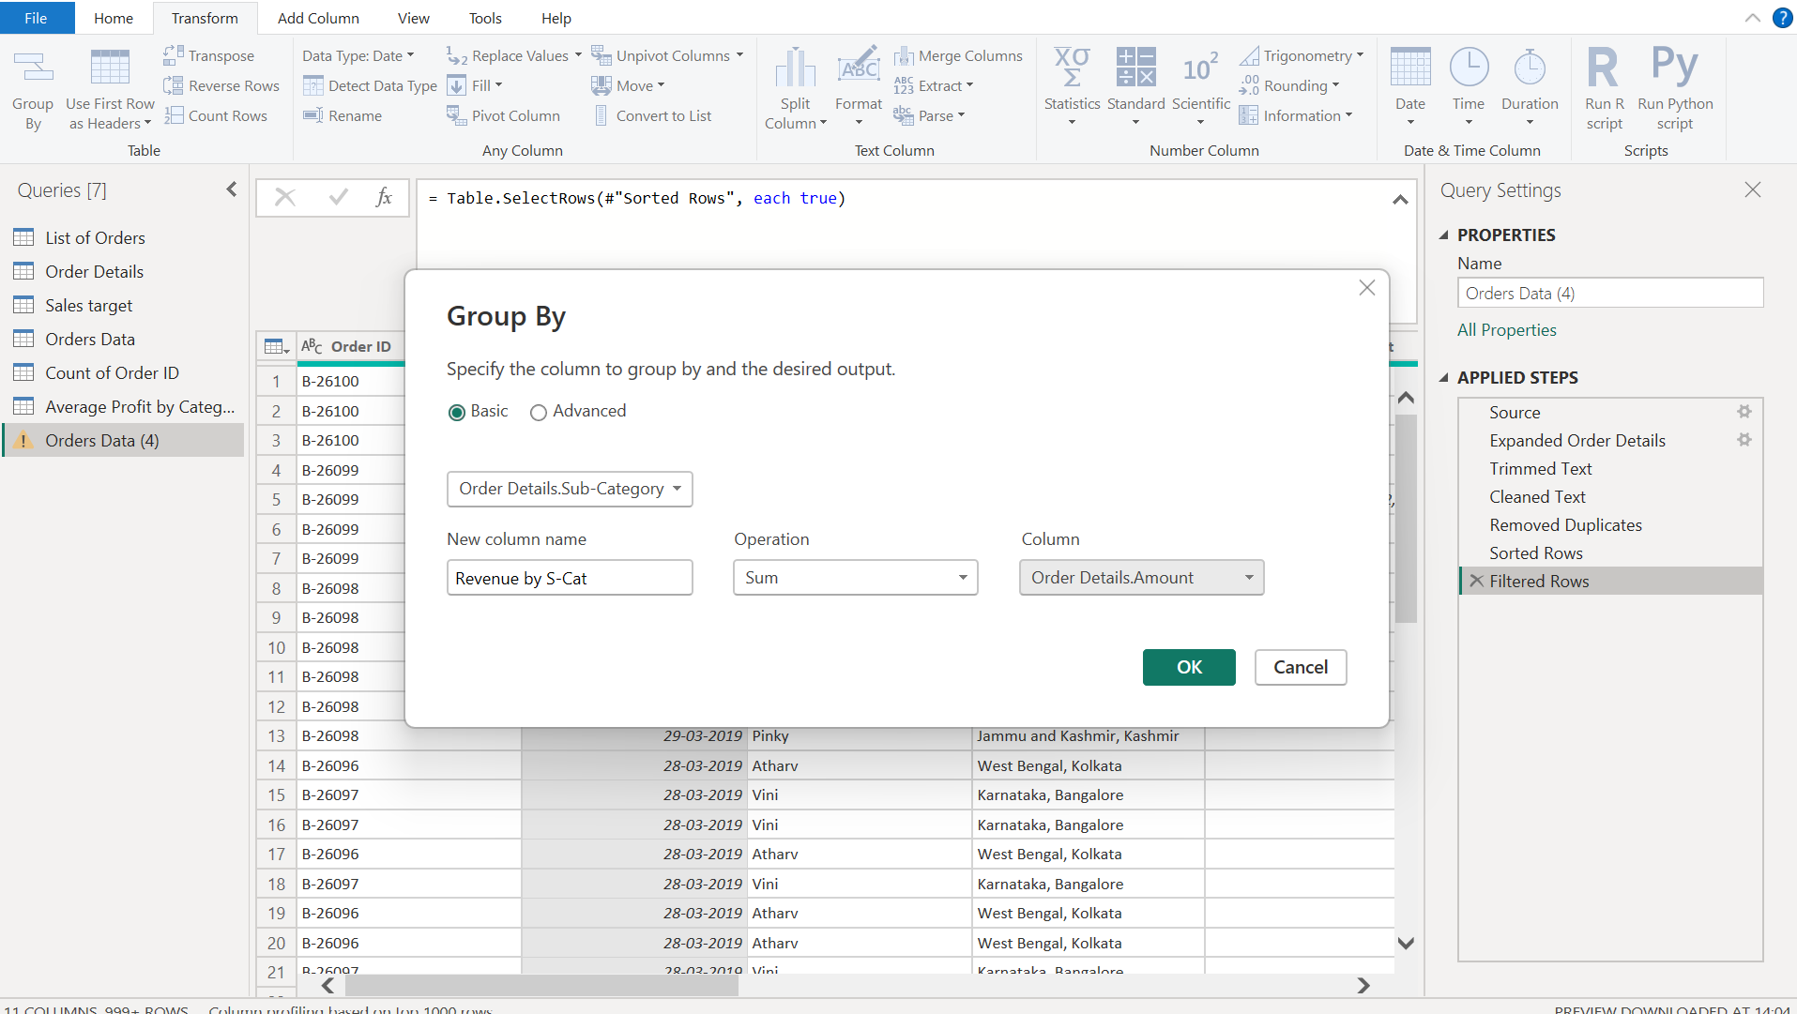

Step 32: Total amount by Sub Category result
The result lists the total amount for each of the 17 sub-categories, for example Printers 58,252, Bookcases 56,861 and Saree 53,511.
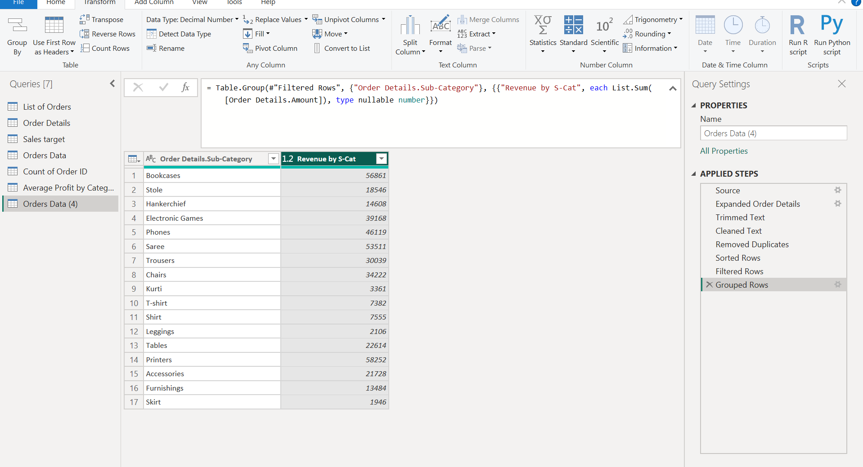

7. Data Modeling

Step 33: Relationship between List of Orders and Order Details
After clicking Close & Apply, open Model view from the left pane, List of Orders and Order Details are connected through Order ID. The 1 on the List of Orders side and the * on the Order Details side show a one-to-many relationship (one order ID under List of Orders table has the same order ID listed many times in the Order details table).
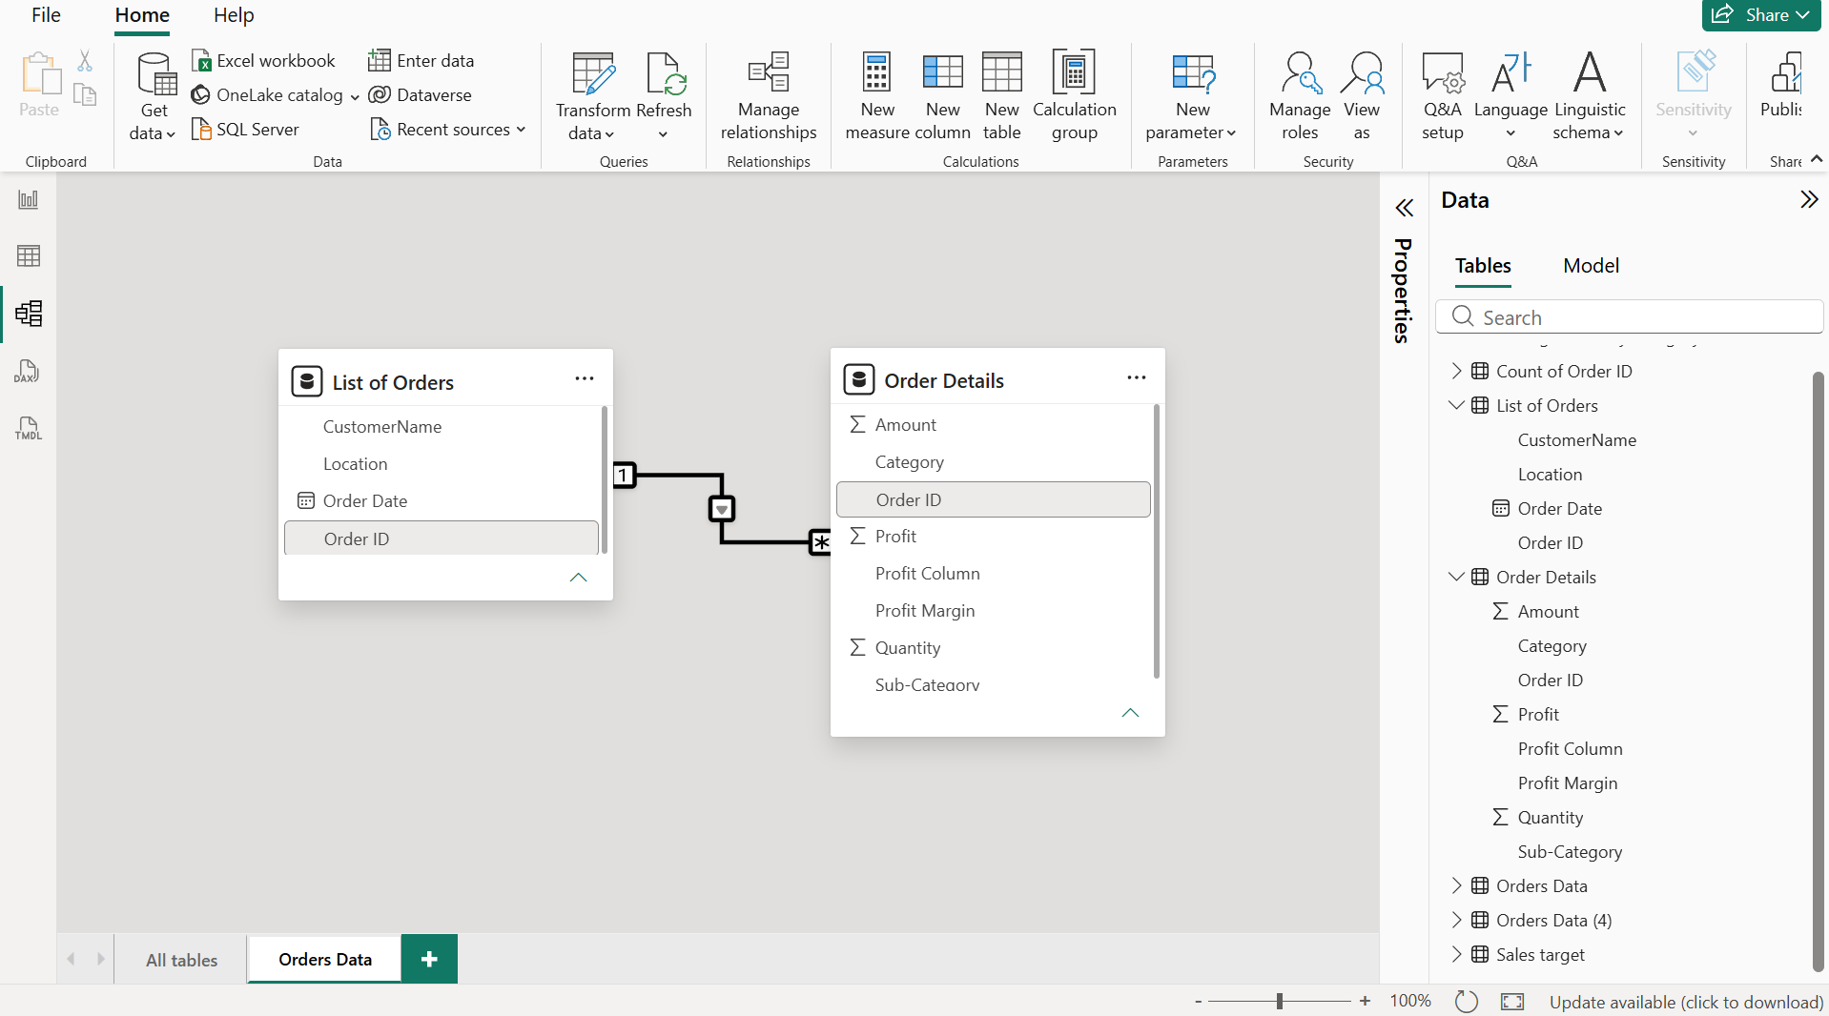

Step 34: Manage relationships
Home > Manage relationships lists every relationship in the model. The selected row connects Order Details (Category) with Sales target (Category) and is marked Active.
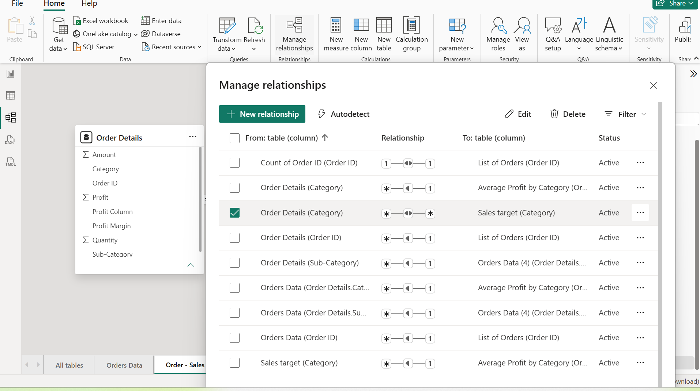

Step 35: Relationship between Order Details and Sales target
In the Order - Sales view, Order Details and Sales target are linked through the Category column. Category repeats in both tables, so this is a many-to-many relationship.
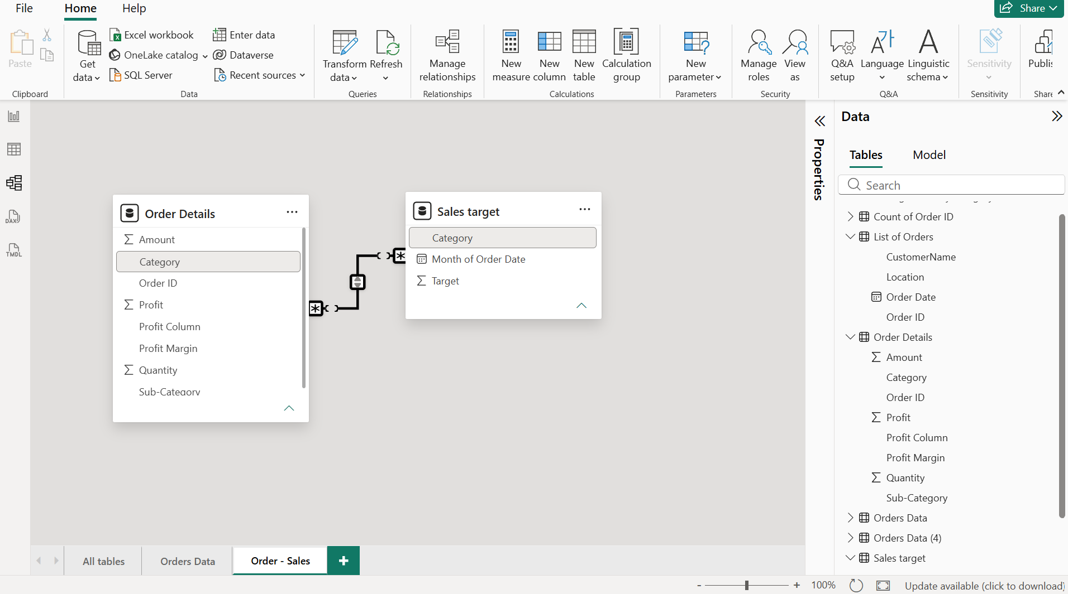

  - In this assignment we have done Importing, transforming, merging and modelling the Orders data Assignment.

